Assignment 2: Accessing Data Part I

Part I

1. SELECT * FROM employees;

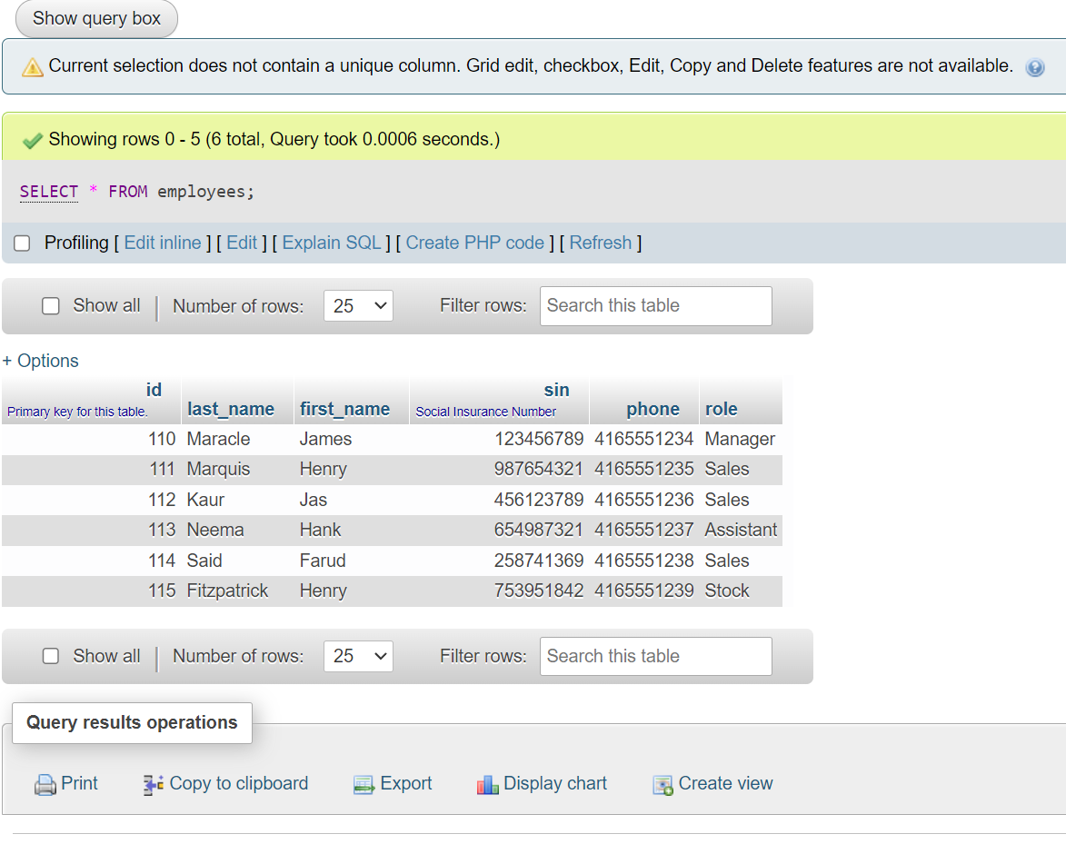

1. SELECT * FROM stock_items;

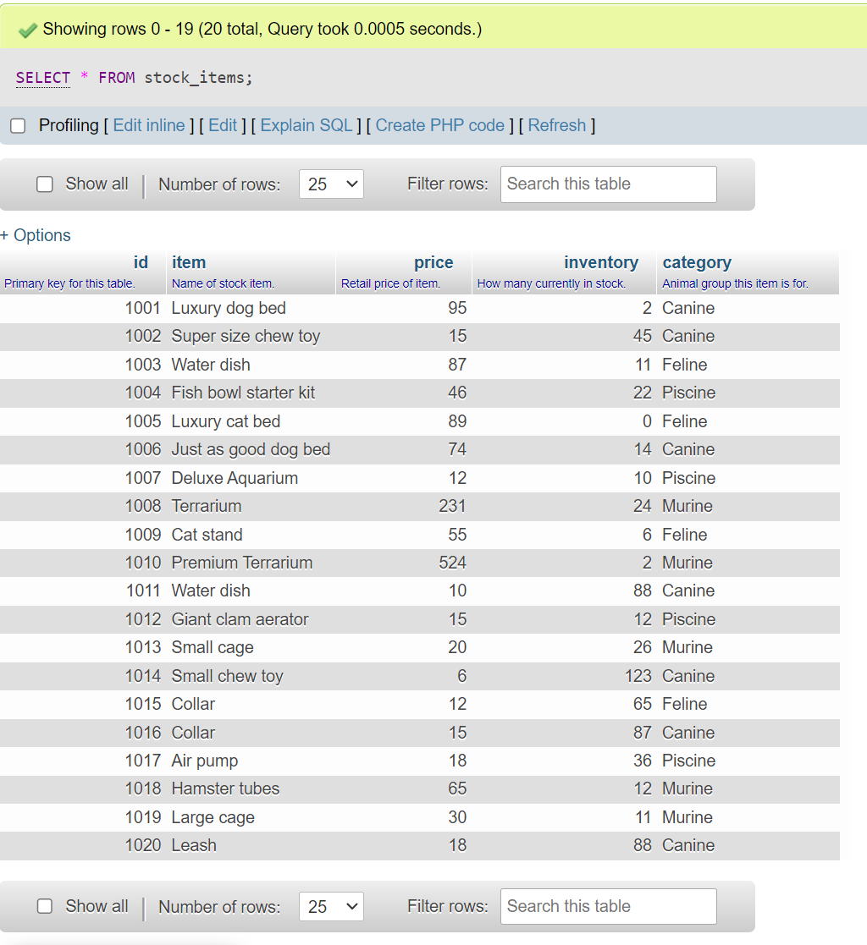

Part II

1. SELECT item, price FROM stock_items;

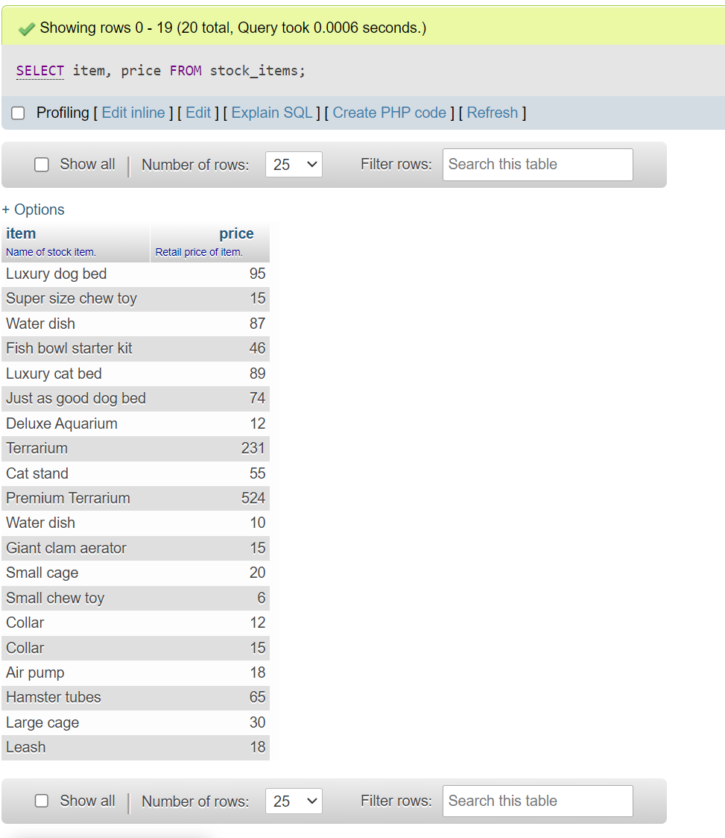

1. SELECT first_name, last_name, role, phone FROM employees;

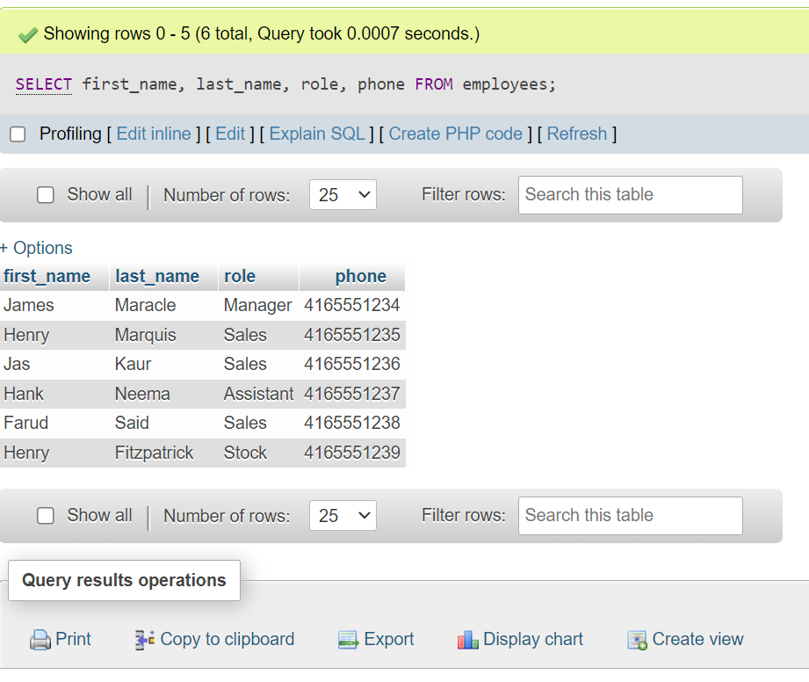

Part III

1. SELECT item AS "Product", category AS "Animal" FROM stock_items;

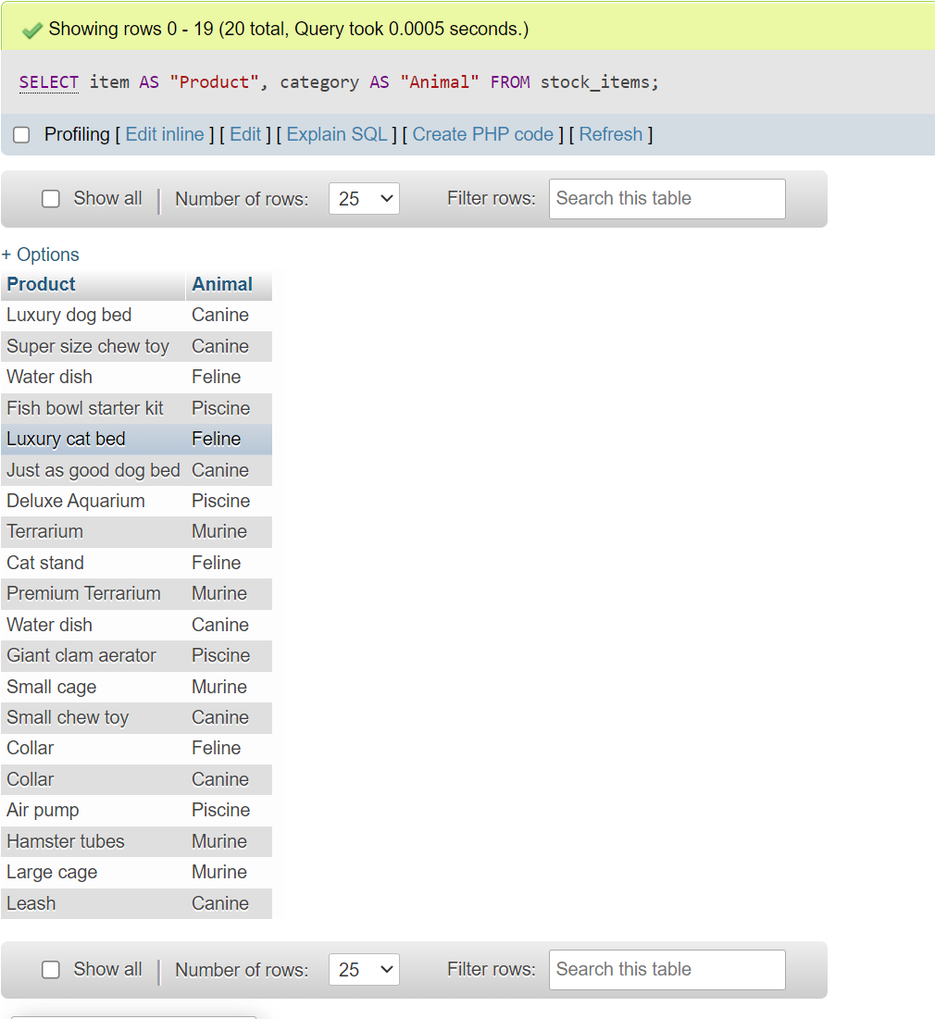

1. SELECT last_name AS "Pet Store Staff", id AS "Emp. ID", sin FROM employees;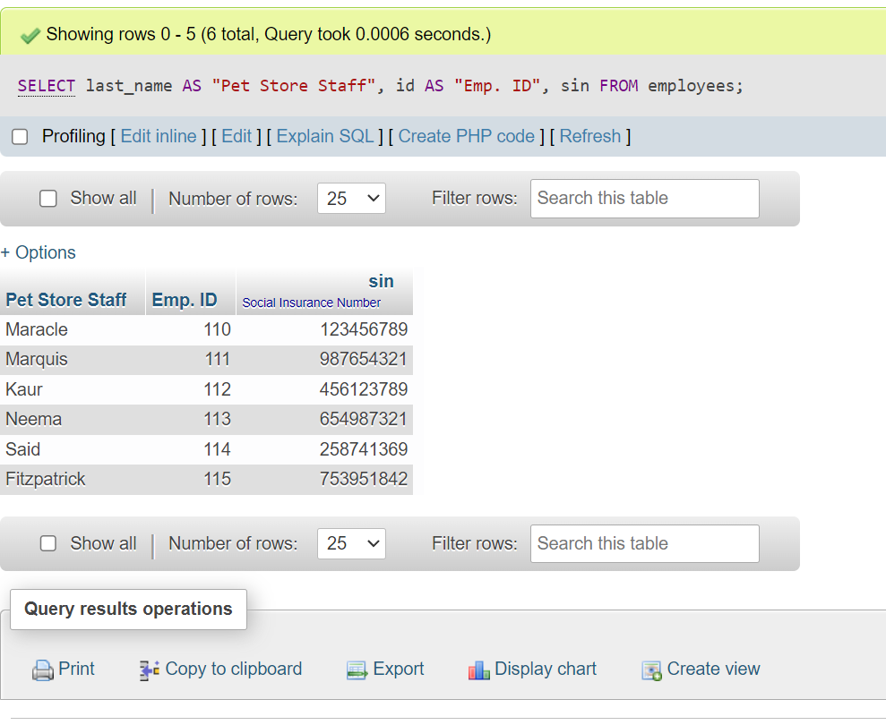

Part IV

1. SELECT first_name, phone FROM employees WHERE role = "Sales";

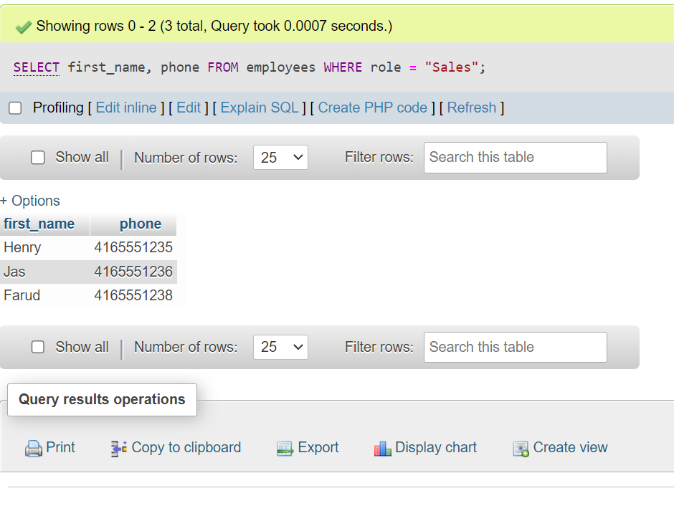

1. SELECT item, id, inventory FROM stock_items WHERE inventory <= 12;

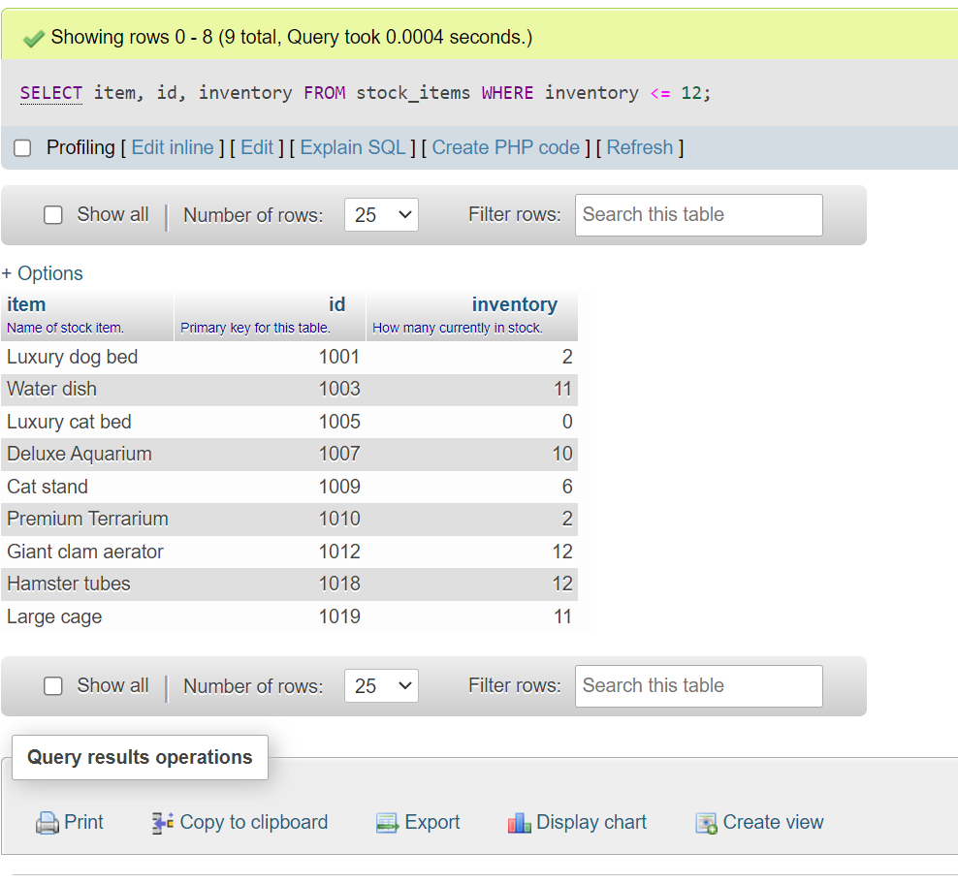

Part V

1. SELECT item, price FROM stock_items WHERE category = "Feline";

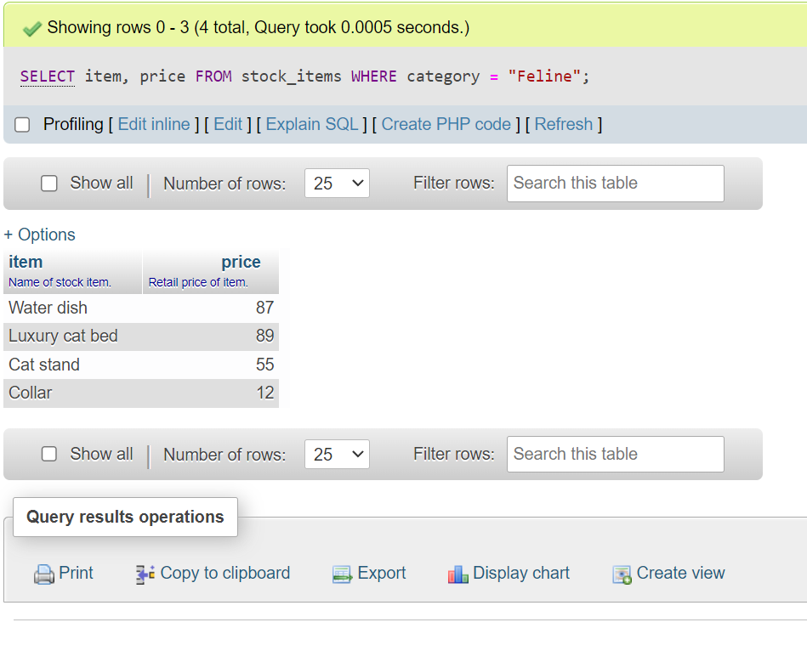

1. SELECT CONCAT (first_name, " ", last_name) AS "Staff Member", id FROM employees WHERE id = 115;

